STUDY MATERIAL
MODULE: 2/2
CLASS: VII
SUB: ENGLISH (HONEYCOMB)
CHAPTER: 3 GOPAL AND THE HILSA FISH

Recaptualtion:
- Who was Gopal?
- Why was the king angry?
- What was the challenge given to Gopal?
- What preparation did Gopal make to complete his challenge?

So far you have read that it was the season for Hilsa fish and everybody was talking about nothing but Hilsa. The king’s court was not an exception. Leaving the state affairs aside, the courtiers were also involved discussing about Hilsa. Even Gopal , one of the brilliant courtiers in the king’s court was found talking about Hilsa. The king got fed up of it and he wanted no more talk about Hilsa. He threw a challenge to Gopal to bring Hilsa in the court without anyone noticing about it. Gopal accepted the challenge. To accomplish his goal, he made some preparation. He half shaved his face, smeared himself with ash and wore rags and went to market to buy Hilsa fish. His wife opposed but he listened nothing.
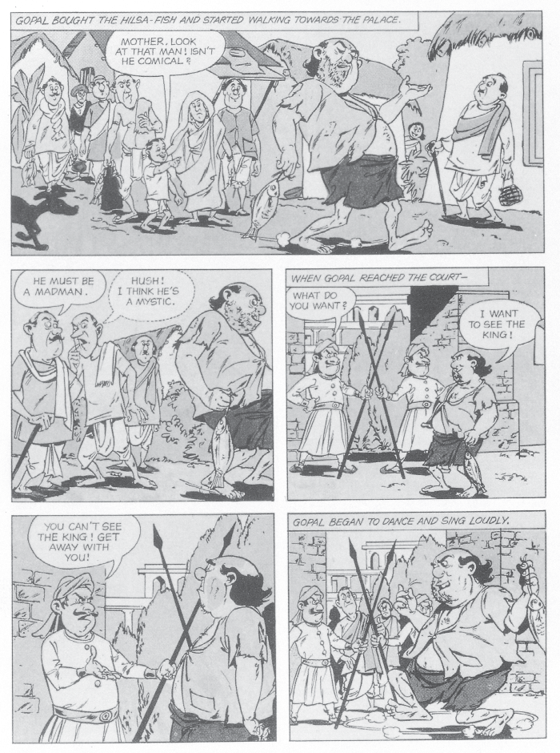
Explanation
At the market Gopal bought a huge Hilsa fish and started walking towards palace. Gopal’s funny appearance attracted the attention of the People much more than the Hilsa fish. No one noticed the fish, but everyone was looking at Gopal walking strangely with his shabby clothes. Some found him comical, some called him mad yet some believed that he was a mystic. Finally, he reached to palace where guards stopped him at the gate. To seek the attention of everyone inside the palace, Gopal started dancing and singing loudly in front of the royal palace.
Words meaning:
i.Comical= funny, silly, entertaining
Eg. She raised her eyebrows comically.
Ii. Mystic = spiritual,
Eg. A mystic traveled around the village telling people’s fortunes and offering cures to curses.
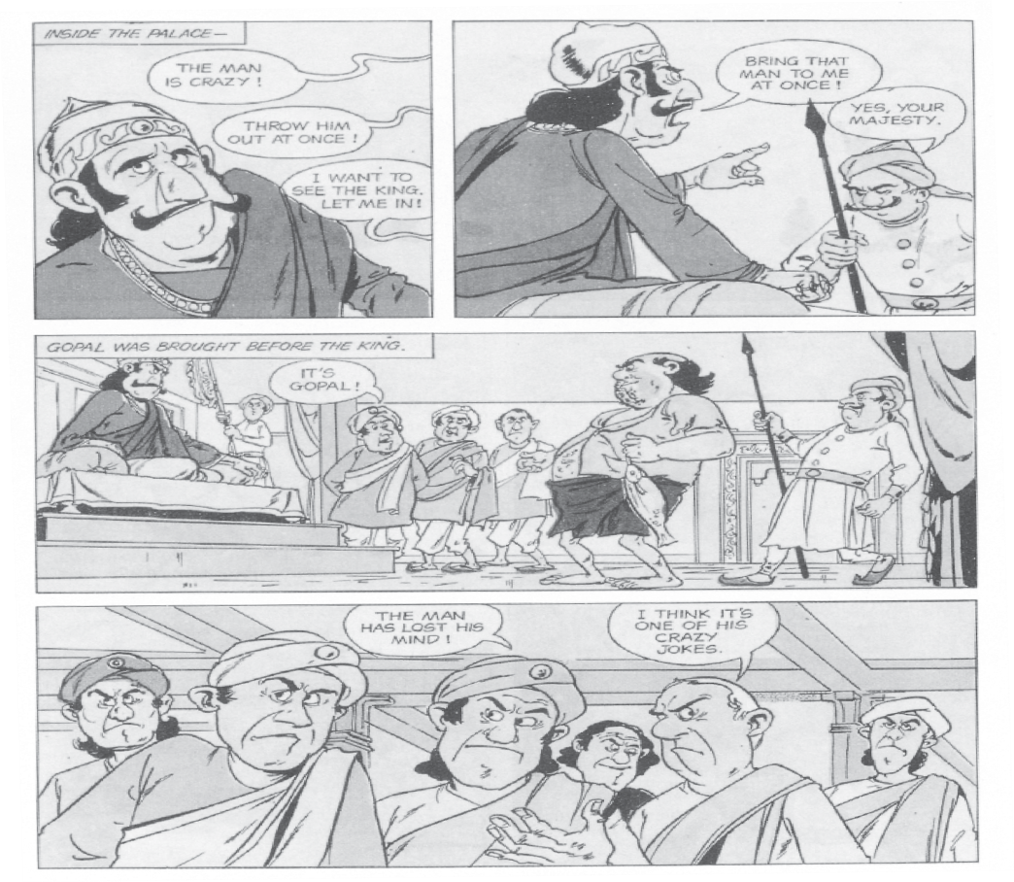

Explanation:
The king heard the commotion happening outside the court and ordered his guards to produce the man before him. Gopal was brought inside the court. Everyone in the court was shocked to see Gopal dressed up like a mad. Courtiers started talking that Gopal had lost his mind.Some believed that it was one of his crazy jokes.But no one noticed the Hilsa fish which Gopal was carrying.

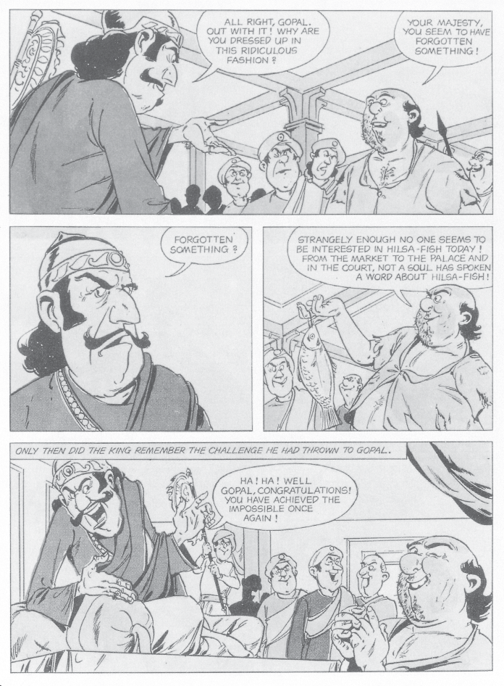

Explanation:
The King questioned Gopal about the reason for his weird attire. Gopal reminded the king about the challenge and told him that from market to the royal palace, no one had asked him a single word about the Hilsa fish. The king burst into laughter and accepted that Gopal had done the impossible task once more.
Words meaning:
i.Ridiculous =foolish, very silly,
Eg. She looks absolutely ridiculous in that hat.
=============================================================================

